Cloning a Remote GitHub Repository in Azure
SOP



Table of Contents

1. Cloning a Remote GitHub Repository in Azure 3
1.1 Description 3
1.2 Architecture Diagram 3
1.3 Lab Steps 4
1.4 Troubleshooting 5
1.5 Supporting References 5

1. Cloning a Remote GitHub Repository in Azure

1.1 Description
Git clone is primarily used to point to an existing repo and make a clone or copy of that repo at in a new directory, at another location. The original repository can be located on the local filesystem or on remote machine accessible supported protocols. The git clone command copies an existing Git repository.
In this lab exercise, we are using azure cloudshell and we will create a local copy of the GitHub repository by cloning a remote GitHub repository.

1.2 Architecture Diagram
The diagram below displays a visual representation of the application architecture:
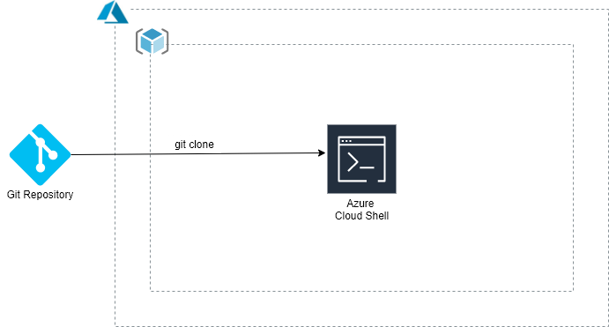

1.3 Lab Steps
Follow the steps outlined below to achieve the objective of this lab exercise:

1. Log In to the Azure Portal and go to your respective resourcegroup (RG): Note: You should have an RG created with your empid.
- Open the Cloud Shell.
Note: Create a new storage account by choosing advanced settings if it does not exist. Azure Cloud Shell is an interactive, authenticated, browser-accessible shell for managing Azure resources. It provides the flexibility of choosing the shell experience that best suits the way you work, either Bash or PowerShell.
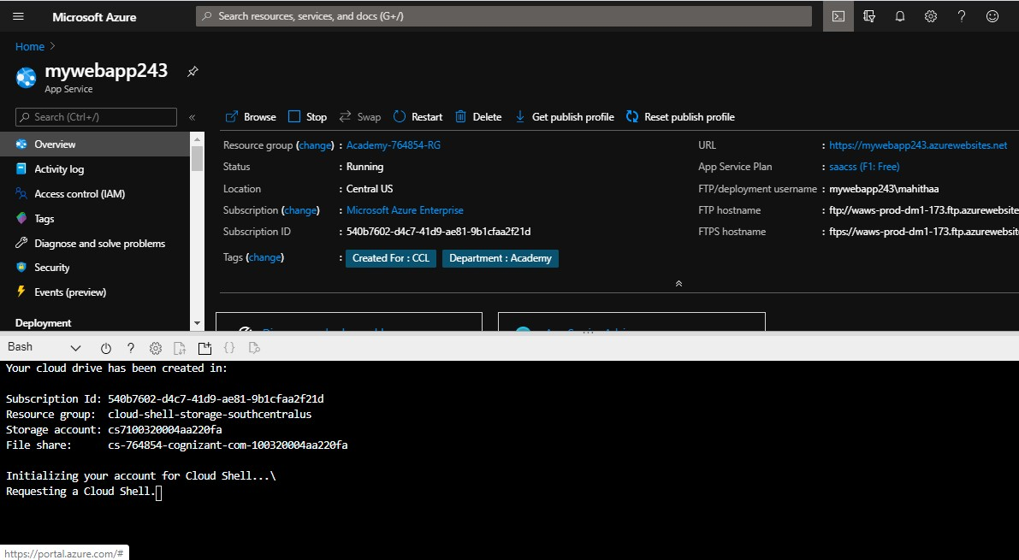

- Enter the following commands to set up your git username and email address. This step is optional and username, email can be anything.
git config --global user.name "<your name>" git config --global user.email "<your email address>"
- Create a local git repository for the source code:
mkdir demoapp cd demoapp
- Clone the Remote Repository to the Local Location. Open your GitHub repository and therein copy the URL that is given in Download or Clone Box.
- Clone it with git clone command. GitHub repository is thus successfully cloned to local repository location:
git clone https://github.com/Azure-Samples/html-docs-hello-world.git cd html-docs-hello-world
Note: In the html-docs-hello-world folder you can find the files of the GitHub project which

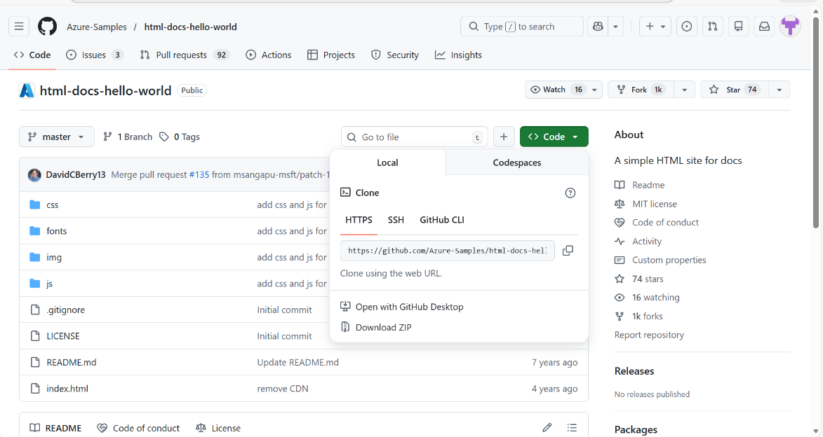
are created as a local repository.
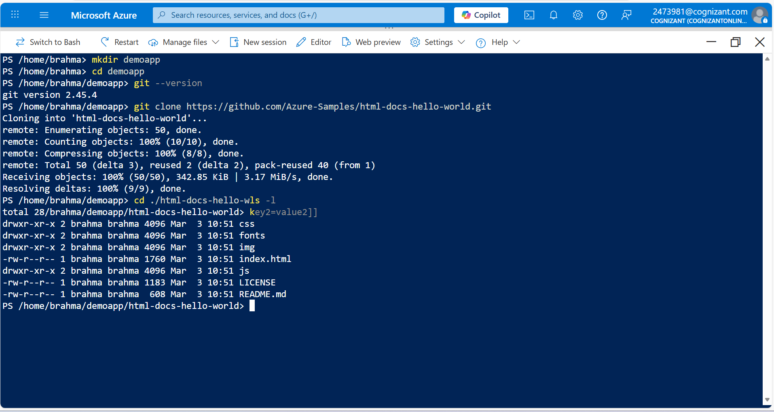
You have successfully cloned a GitHub project to local repository.

1.4 Troubleshooting
S. No | Problem | Solution
1 | Cannot connect local to remote repository | Firstly, check that the repository on GitHub is not private. Moreover, use https for connection.
2 | Unable to create storage account for Cloudshell. | Make sure that you are creating the storage account in the correct region.

1.5 Supporting References
Refer the below link for additional information:

1. https://docs.microsoft.com/en-us/azure/application-gateway/quick-create-portal

